EX. NO.: 11
TITLE
DATABASE WITH AUTO_INCREMENT SEQUENCES
AIM
To create Auto Increment sequence on the given relation.

PROCEDURE
- Select the MobileDB database.
- Create a new table named MobileSales_Auto with an auto-increment column.
- Insert records without specifying a value for the auto-increment column.
- Display the records and verify that the ID values are generated automatically.
- Insert another record and verify that the next sequence number is generated automatically.
- Observe and verify the Auto Increment sequence.

COMMANDS
1. Select Database
USE MobileDB;
2. Create Table with AUTO_INCREMENT
CREATE TABLE MobileSales_Auto
(
MobileID INT AUTO_INCREMENT PRIMARY KEY,
MobileName VARCHAR(20),
Price INT,
CustomerReview DECIMAL(2,1),
UnitsSaled INT,
ModelYear INT,
Storage INT
);

3. Insert Records
INSERT INTO MobileSales_Auto
(MobileName, Price, CustomerReview, UnitsSaled, ModelYear, Storage)
VALUES
('OnePlus14R',25000,4.0,10000,2025,128),
('Redmi12',20000,4.0,10000,2024,128),
('SamsungS10',30000,4.1,5000,2023,256),
('iPhone12',45000,3.9,4000,2024,128),
('MotoG36',21000,4.0,2000,2025,128);

4. Display Records
SELECT * FROM MobileSales_Auto;

5. Insert Another Record
INSERT INTO MobileSales_Auto
(MobileName, Price, CustomerReview, UnitsSaled, ModelYear, Storage)
VALUES
('Pixel6A',30000,4.5,5000,2024,256);

6. Verify the Auto Increment Sequence
SELECT * FROM MobileSales_Auto;

7. Display Table Structure
DESC MobileSales_Auto;

OUTPUTS

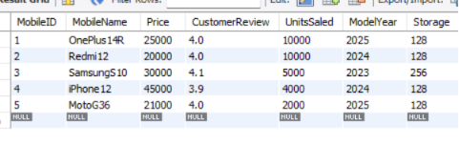
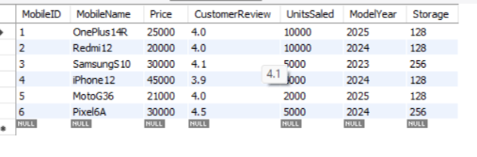
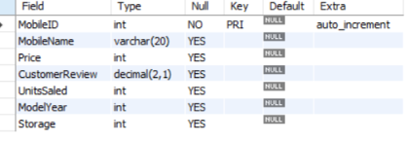

RESULT
Thus, the Auto Increment sequence was successfully created and verified on the MobileSales_Auto relation.

